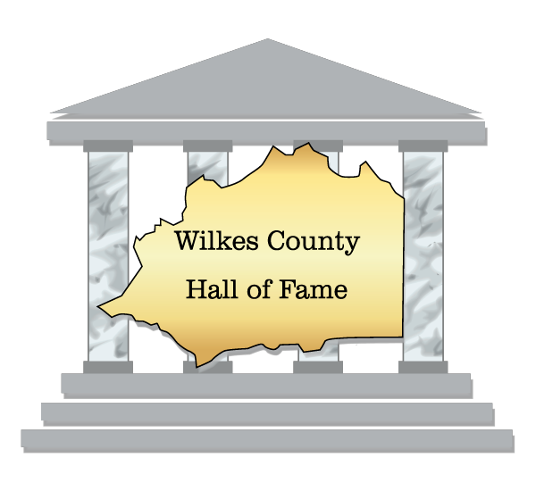
Wilkes County Hall of Fame Nomination Form
Thank you for nominating someone you know, or yourself, for the Wilkes County Hall of Fame. Candidates must meet the following criteria:
• The nominee must have lived in and contributed to the betterment of Wilkes County.
• The nominee must have made a broad and lasting impact to his/her community, or brought recognition to the community through their accomplishments.
• The nominee must be of exemplary character and reputation.

For your nominee to be considered for the Class of 2026, please fill out the following application completely and submit to the Wilkes County Hall of Fame no later than November 30, 2025. If you would prefer to submit your own document, please make sure all information contained in this document is included in your submission. Additional documents outside of this application are welcomed.

Email Your Nominee To: wilkescountyhalloffame@gmail.com Please put “WCHOF Nomination” in your subject line.

Please choose category from choices below

Nominees Category of Application -

Arts & Entertainment - Renowned performers, musicians, actors & actresses, poets & writers and those who work in related fields

Enterprise - Wilkes County greats in such fields as science, medicine, business and philanthropy.

Sports - Superior Athletes, coaches, officials, and administrators in the wide world of sports.

Leadership - Greats who may not well fit into the above categories, e.g. educators, military leaders, etc.
Individual Nomination - Nominees Information

First Name Middle Last Name Age Date of Birth Place of Birth Work Phone Home Phone Cell Phone Email Address
Name of High School Year of Graduation

Name of College Year of Graduation

Additional Degree(s) Dates (if applicable)

Complete the following information if Nominee is Deceased

Date of Death

Contact information of Closest Known Living Relative Name Relation to Nominee
Phone Number
Street Address

City State Zip Code
Educational Honors

Please list any Awards, Scholarships, Honorary Degrees, etc. the nominee may have received.

Key Success Stories

These stories demonstrate strength in the category nominated for and may include Awards, Newspaper articles, web page articles, biography, etc.
Community Involvement

This may be in local civic organizations, churches, non-profits and volunteering. It is personal time donated to community with no compensation.

Philanthropy

How has/did the nominee give back some of what the community has given to them.
Accomplishments

Awards and recognition presented to individual for outstanding achievement in or outside of
Wilkes County. Please be specific.

Exemplary Character and/or Reputation

Please include examples typical of the nominee’s character and/or reputation. This can include but is not limited to letters or recommendation, newspaper articles, etc.
Additional Information

Providing additional information or artifacts other than those listed on this form will strengthen an application and may improve a nominee's chances for selection to the Hall of Fame.

Sponsor Contact Information (Person completing this form)

First Name Middle Name Last Name

Street Address

City State Zip Code Work Phone Home Phone Cell Phone Email Address

